**ASSIGNMENT-06**

**Question #1:**

Write a c program that creates a menu. Consider the following layout Write a message while selecting the option i.e., if you are selecting save file, then print the option as “Saving File”.

**Source Code:**

**Output:**

**Question #2:**

Write a C program to check isosceles, scalene, or equilateral triangle when sides are given using conditional operators.

**Source Code:**

**Output:**

**Question #3:**

Write a program in which user enters his NTS and F.Sc marks and your program will help student in selection of university. Based on these marks Student will be allocated a seat at different department of different university.

**Source Code:**

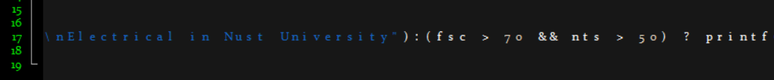







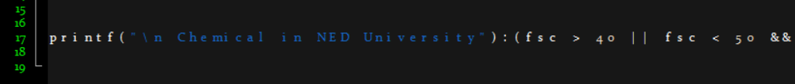





**Output:**

**Question #4:**

Write a program to control a coffee machine. Allow the user to input the type of coffee as B for Black and W for White. Ask the user if the cup size is double (d) and the cup size is single(s). The following table details the time chart for the machine for each coffee type. Display a statement for each step. If the coffee size is double, increase the making time by double. Use functions to display instructions to the user and to compute the coffee time.

Source Code:**

**Output:**

**Question #5:**

The National Earthquake Information Center has asked you to write a program implementing the following decision table to characterize an earthquake based on its Richter scale number.

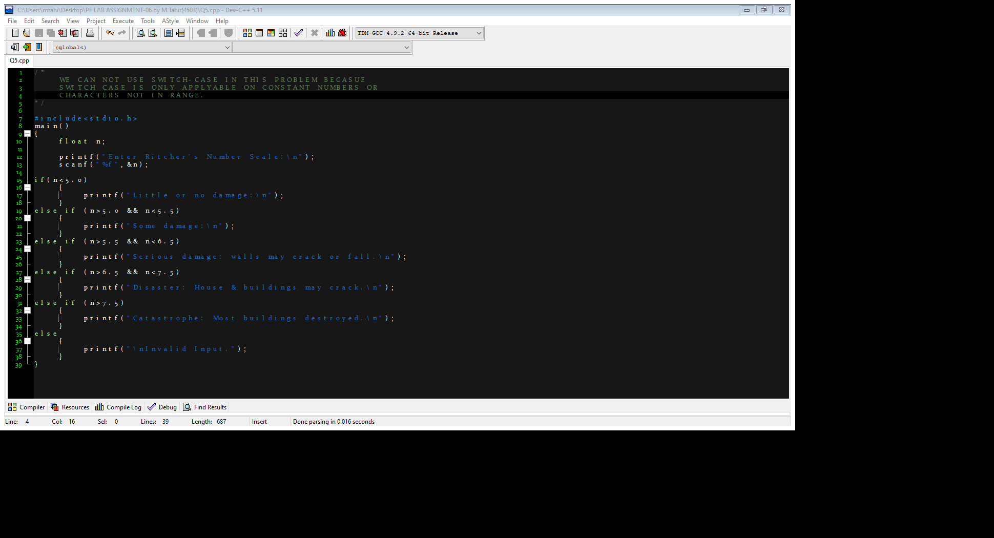**Source Code:**

**Output:**

**Question #6:**

Write a program to calculate the fares of seats in the train. The train has three classes i.e., Economy, AC standard, Business Class. The user will provide the number of seats in any one of the classes mentioned earlier. The user can also compute fares of seats of any combination of the classes (Economy, AC Standard, Business Class). For Example, the user wants to calculate the fares of two seats in Economy class, 2 seats in Business class and two seats in Ac Standard class. Seat in Economy class has fare equals 600 Rs. Seat in Ac standard class has fare equals 1000 Rs and Seat in business class has fare equals 2000Rs.

**Source Code:**

**Output:**

**Question #7:**

Write a c program that prints “I will go to school” if the days are weekdays. Otherwise, the program should print “I will go to play cricket”.

**Source Code:**

**Output:**

**Question #8:**

A local shop sell three items. Items are USB, Handfree and charger. USB costs 800 Rs, Handfree costs 1000 Rs, charger costs 2000 Rs. The user can buy 1 item or the combination of any number of items. After selecting the item to be purchased the program should take input the number of USBs or Handfree or Charger, then compute the total amount. Sample output is attached below:

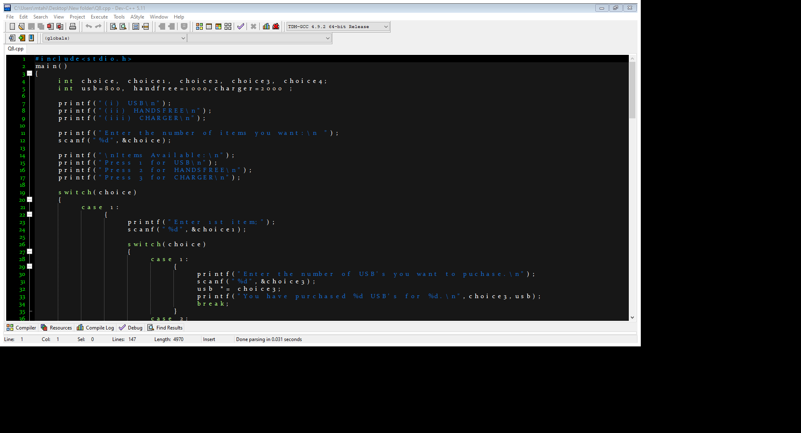**Source Code:**

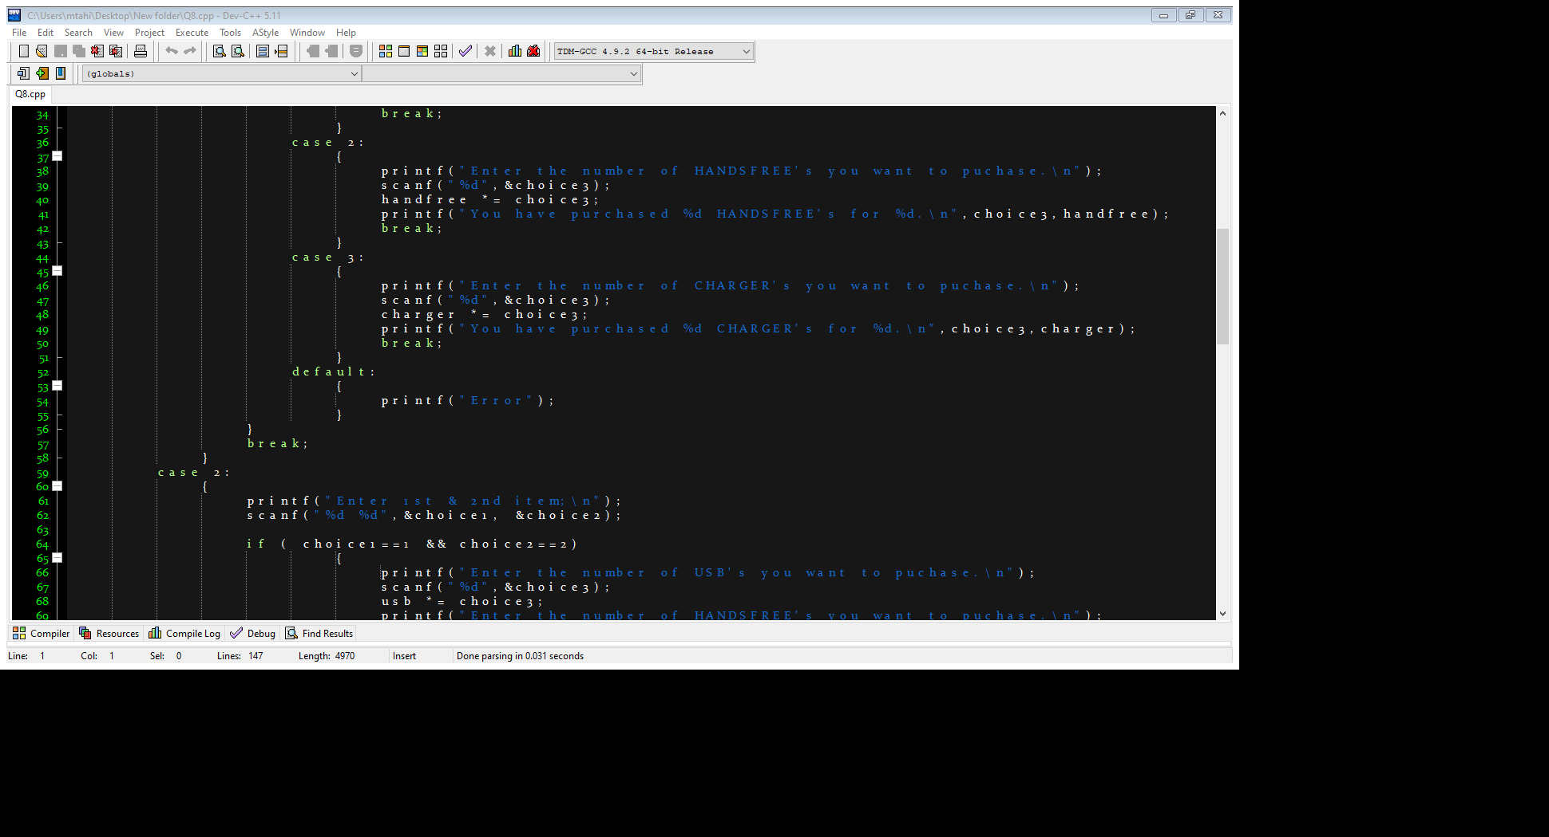

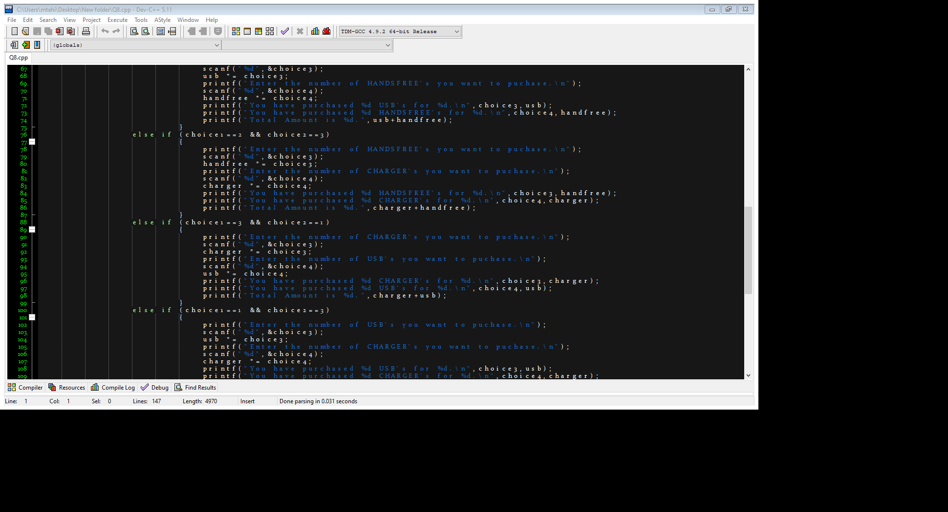

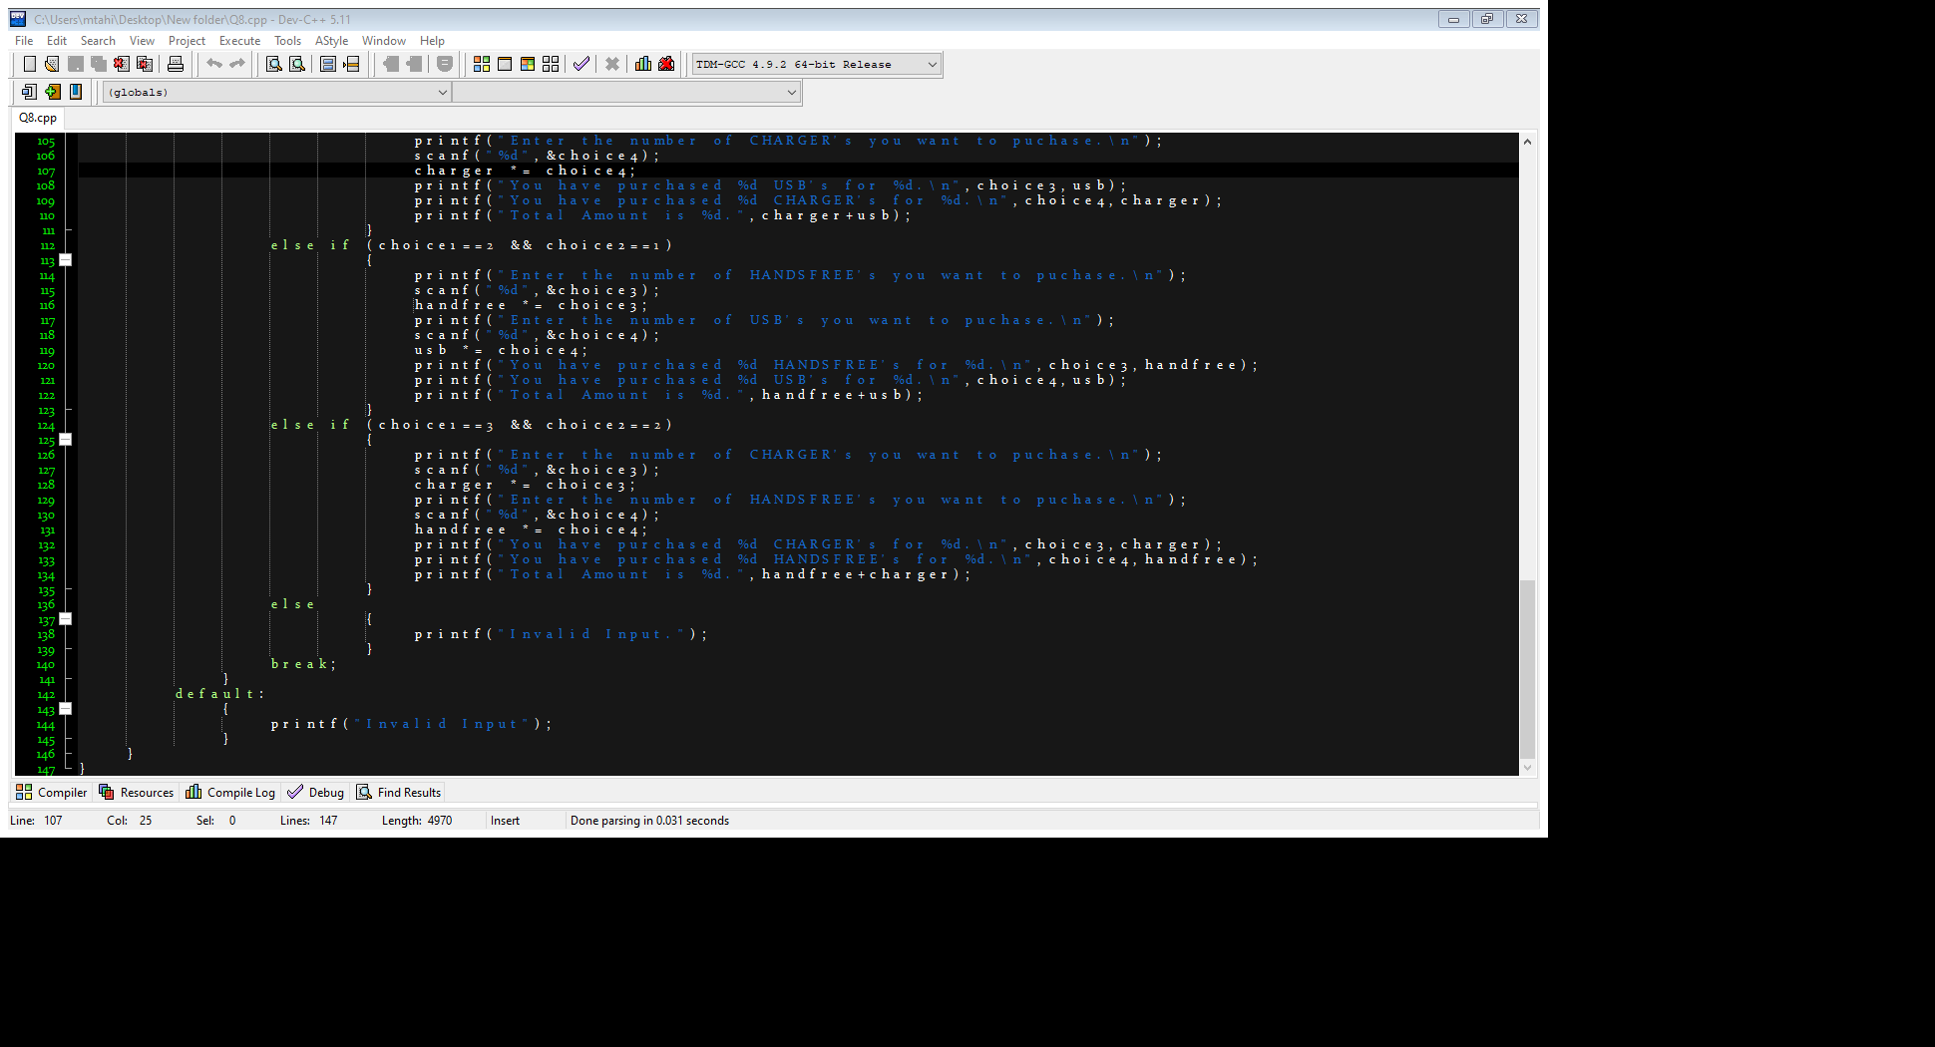

**Output:**

